**Name:** Pueria lobata, Kudzu, Ko Ken, Ge Gen, Kuzu, Japanese arrowroot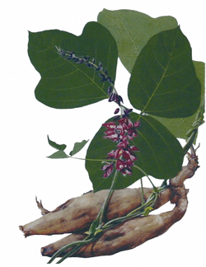

**Similarly Used Species:** B. bipinnata (gui zhen cao, nian shen cao), B. biternata, B. chinensis, B. parvif ora (xiao hua gui zhen cao) B. tripartite, B. chilensis

**Family:** Fabaceae…it is a legume

**Location:** Native to most of eastern and southeasternAsia and some Pacific Islands.Has spread and now grows aggressively in Africa, North America, The Dominican Republic, Jamaica, Panama, Brazil & Paraguay. Was introduced to America as an ornamental shrub and was used for soil erosion and shade.

**Description:** climbing, coiling, trailing, semi woody, deciduous, fast growing hardy perennial vine that spreads quickly and is hard to eradicate. Can grow up to 12 inches per day and up to 100 feet per year. Has hairy dark brown stems. Forms large root tubers. Leaves are alternate with three leaflets and usually slightly lobed. Flowers are pea like and pink to purple with yellow centers, highly fragrant, and borne in long hanging panicles.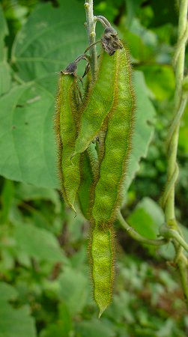 Fruits grow in brown hairy pods. It will grow almost anywhere there is full sunlight with moist conditions. Although it has been known to tolerate drought and freezing conditions.

**Parts Used:** Roots & Flowers

**Uses:** has been used for thousands of years in China, the starch is used as a thickener is soups, desserts and beverages,Has been used to improve soil quality and to prevent erosion, fiber used for paper and clothing,

Colds, Influenza and SARS by reducing the cytokine cascade, digestive/intestinal disturbances, Increases blood circulation, Relieves tension in the neck & face, Neutralizes acid in the body thus reducing minor aches & pains,Will reduce damage by cytokines in the central nervous system, Strongly protective of the brain and the central nervous system-protects mitochondria & stimulates peripheral nerve regeneration in the brain, Reduces neurotoxicity, Reduces autoimmune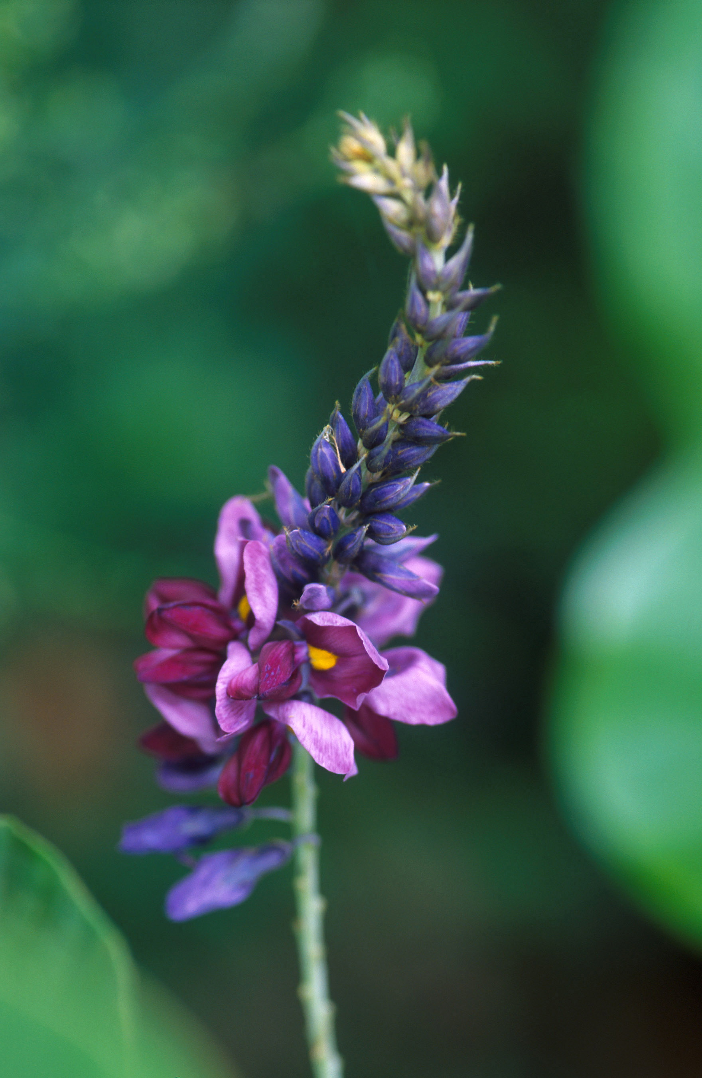 reactions in the brain, Anti-inflammatory (reducing inflammatory cytokine cascades) especially in the brain and central nervous system, Somewhat anti-viral, Lowers blood pressure, Reduce Bell’s Palsy, Reduces Fevers, Viral Encephalitis, Chronic Fatigue, Reduces nerve pain, Ischemia or Injury to the Brain, Tinnitus, Vertigo, Alzheimer’s Disease, Hangover Headache, Stimulates regeneration of liver tissue, Leukemia, Breast Cancer, Diarrhea, Dysentry, Gastroenteritis, Measles, Rash eruptions

**Actions:** Antipyretic, Refrigerant, Diaphoretic, Spasmolytic, Demulcent, Neuroprotective, Neuroregenerative, Antioxidant, Hypotensive, Stimulant to the Spleen, Anti-tumor

**Constituents:** contains Daidzen(an isoflavone) which is a phytoestrogen and has anti-inflammatory and antimicrobial properties, high in minerals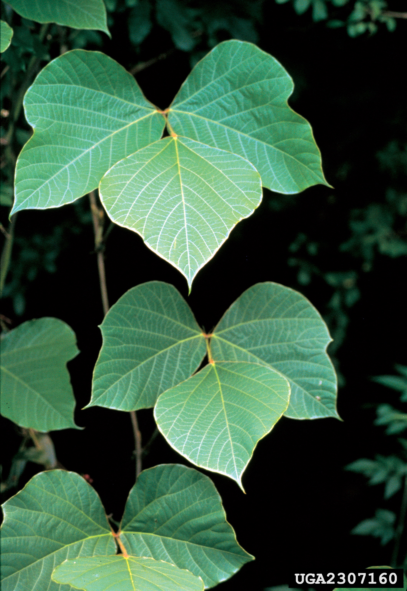 and calcium, puerarin, kakkalide, irisolidone

**Preparation:**

**Tincture:** (1:5 in 50% alcohol)1/2 teaspoon 3-4 times a day

**Thickener in Food:** Tamari Kudzu paste: dissolve 1-1.5 tablespoons of powder into 2 tablespoons of *cold* water or it will clump. Heat in a pan with tamari, ginger, garlic, lemon rind, miso, honey & vinegar.

**Jelly:** use flowers

**Food:** leaves can be boiled and eaten like spinach

**Powdered Root in Capsule:** Traditional Chinese: 6-12 grams per day, in the West: 1 gram per day

**For Colds & Flu:** Mix with a little bit of licorice root powder, ginger powder, cinnamon & soy sauce

**Tea:** roots and blossoms

**Poultice:** crushing the stems

**Harvest:** roots: late fall through early spring, flowers: as they open in mid summer

**Systems Effected:** Lungs and stomach, Brain

**Taste:** Sweet and Acrid

**Energy:** Mild and Neutral

**Psychology:**

**Flower Essence:** tenacity and persistence in the face of emotional setbacks, rejection, abandonment, self denial, self acceptance, isolation from others from a fear of repeating past hurts, helps to maintain personal identity and integrity in relationships, feeling smothered or trapped by the responsibilities and expectations of others,

**Combines:** Ashwaghanda, Cyperus Root, & Black Cohosh for fibromyalgia, celandine for headache pain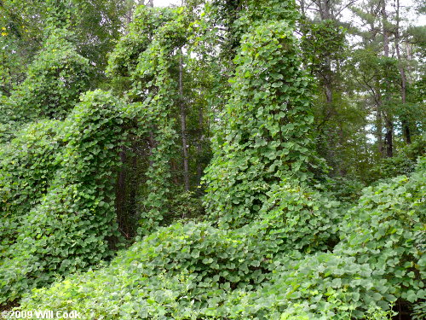

**Constitution:**

**Pulse:**

**Tongue:**

**Temperature:** Cool

**Meridians:** Spleen, Stomach, Lungs, Bladder

**Contra-Indications:** None

**References:**

**The Way of Herbs** by Michael Tierra

**Medical Herbalism** by David Hoffman

**Adaptogens: Herbs for Strength, Stamina & Stress Relief** by David Winston & Steven Maimes

**Healing Lyme Second Edition** by Stephen Harrod Buhner

**Natural Treatments For Lyme Co-Infections: Anaplasma, Babesia, and Ehrlichia** by Stephen Harrod Buhner

**Herbal Antivirals** by Stephen Harrod Buhner

**<https://en.wikipedia.org/wiki/Kudzu>**

**<https://earthkindherbal.com/2011/03/20/pueraria-montana-kudzu/>**

http://www.essences.com/vibration/may01/kudzu.html